Module 9

Robertson, Rashai

Bellevue University, CSD325

Assignment 9.2

04/27/2025

Tutorial – Test the Connection:

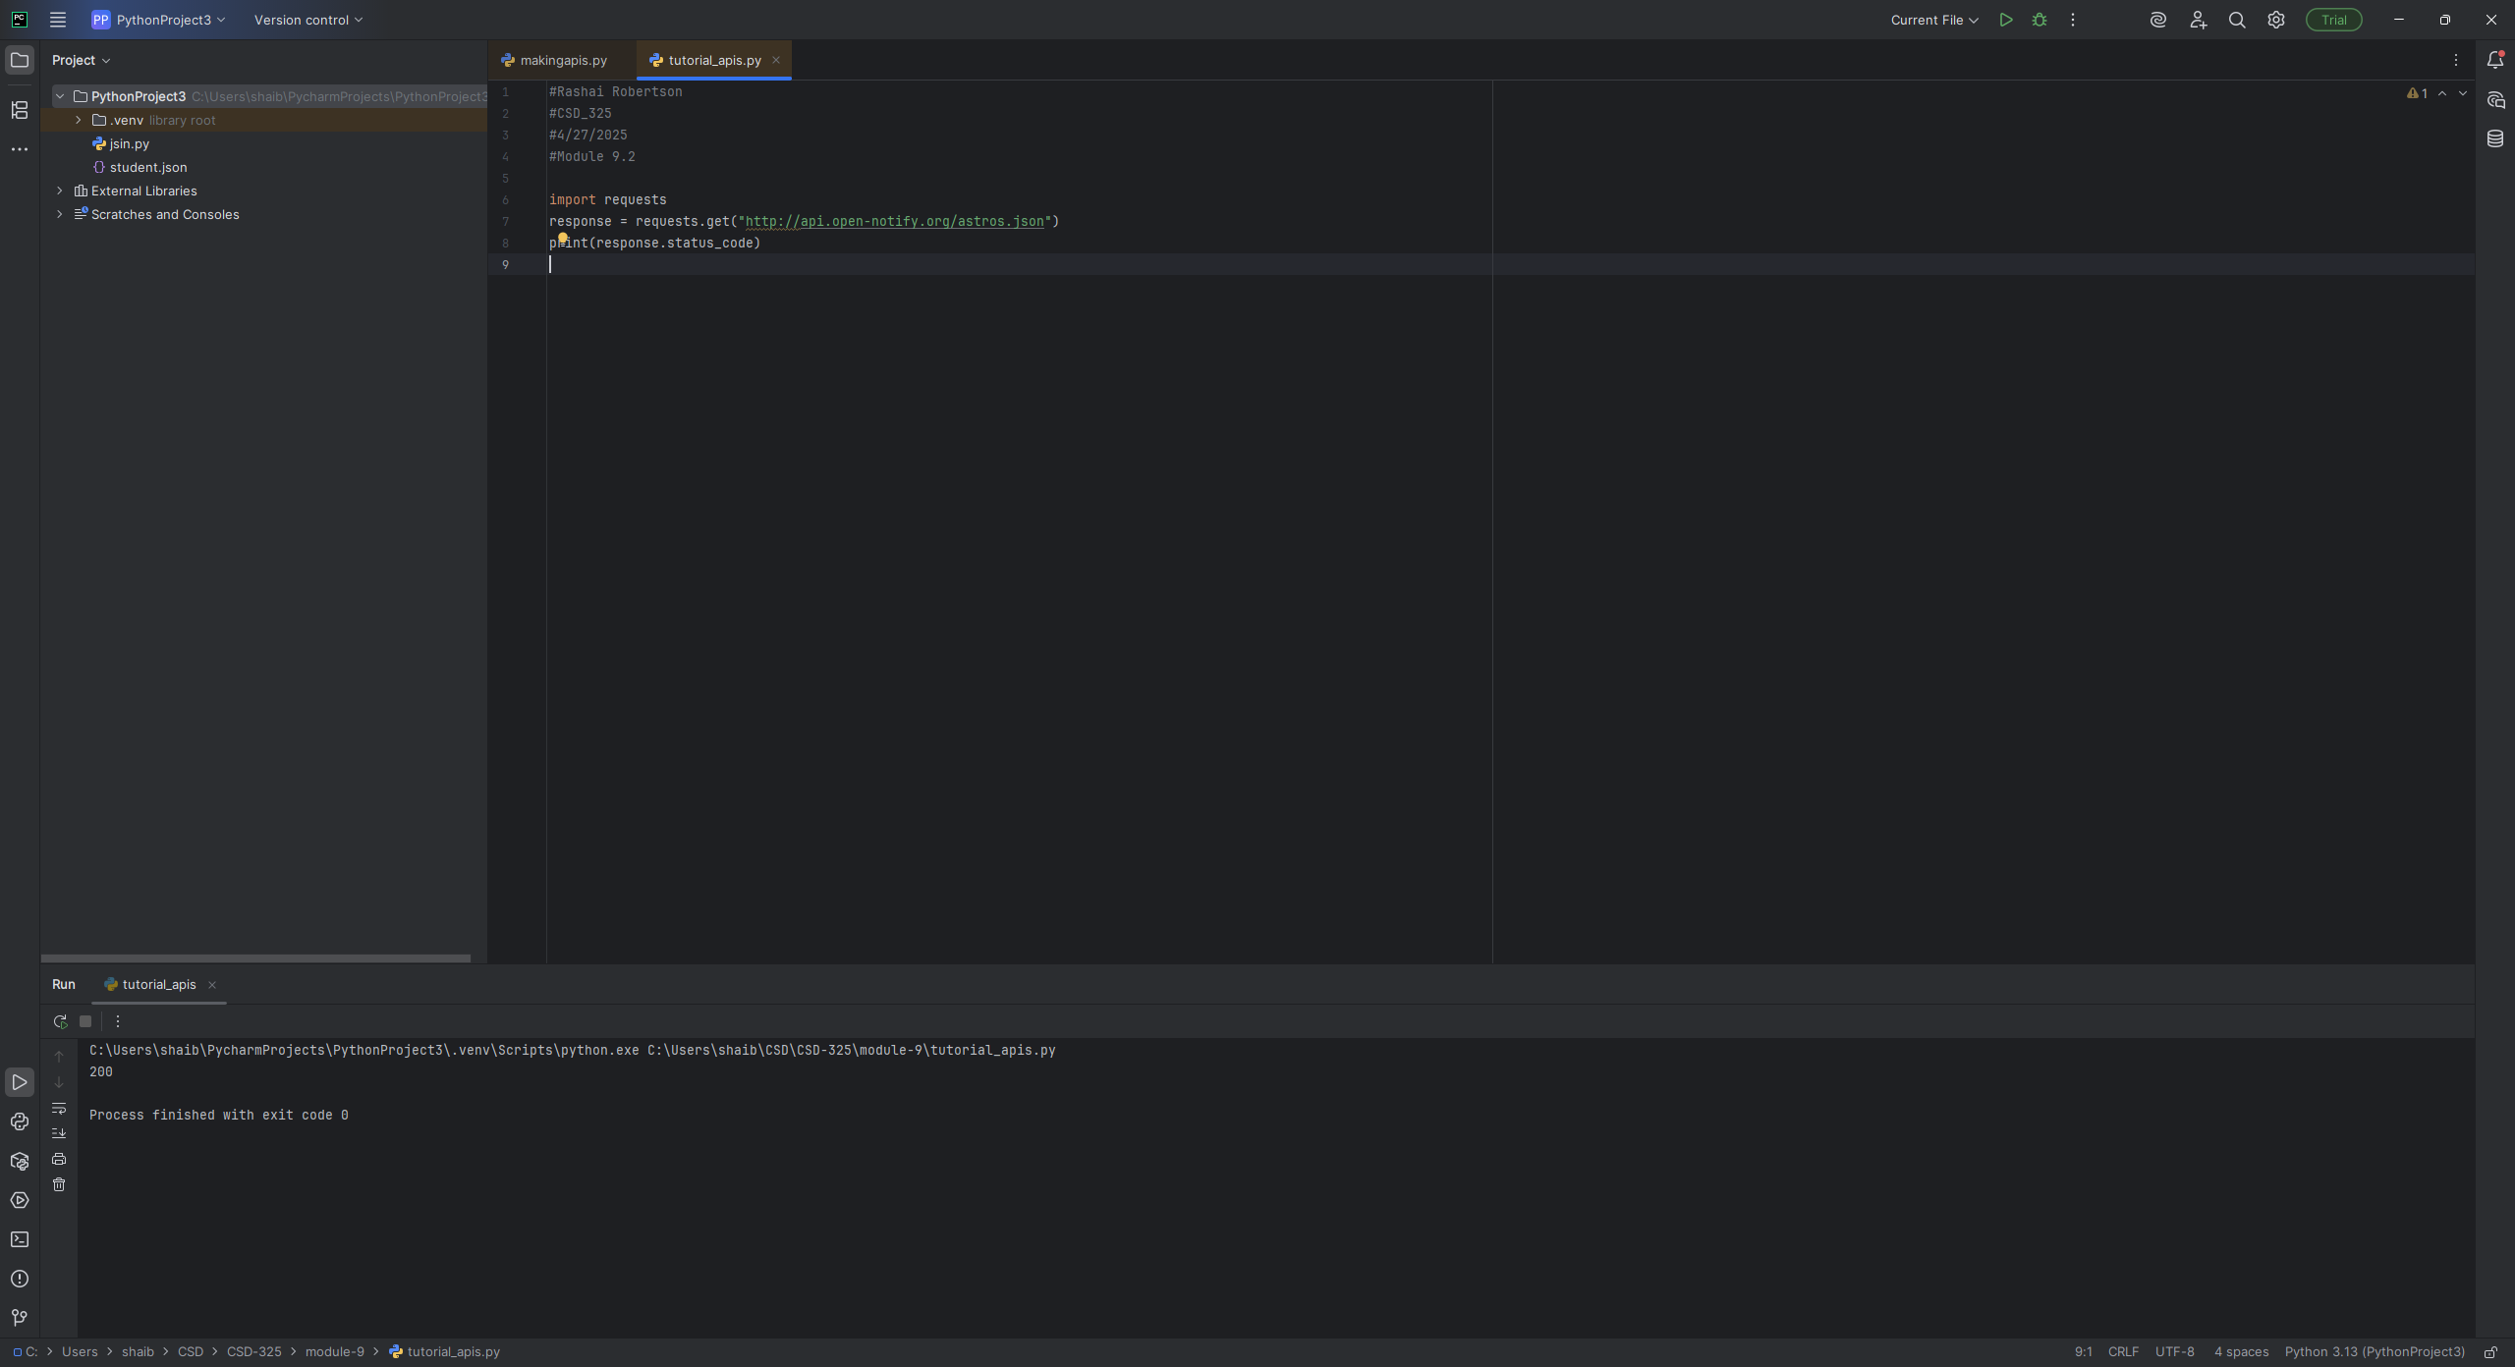

Tutorial – Formatted:

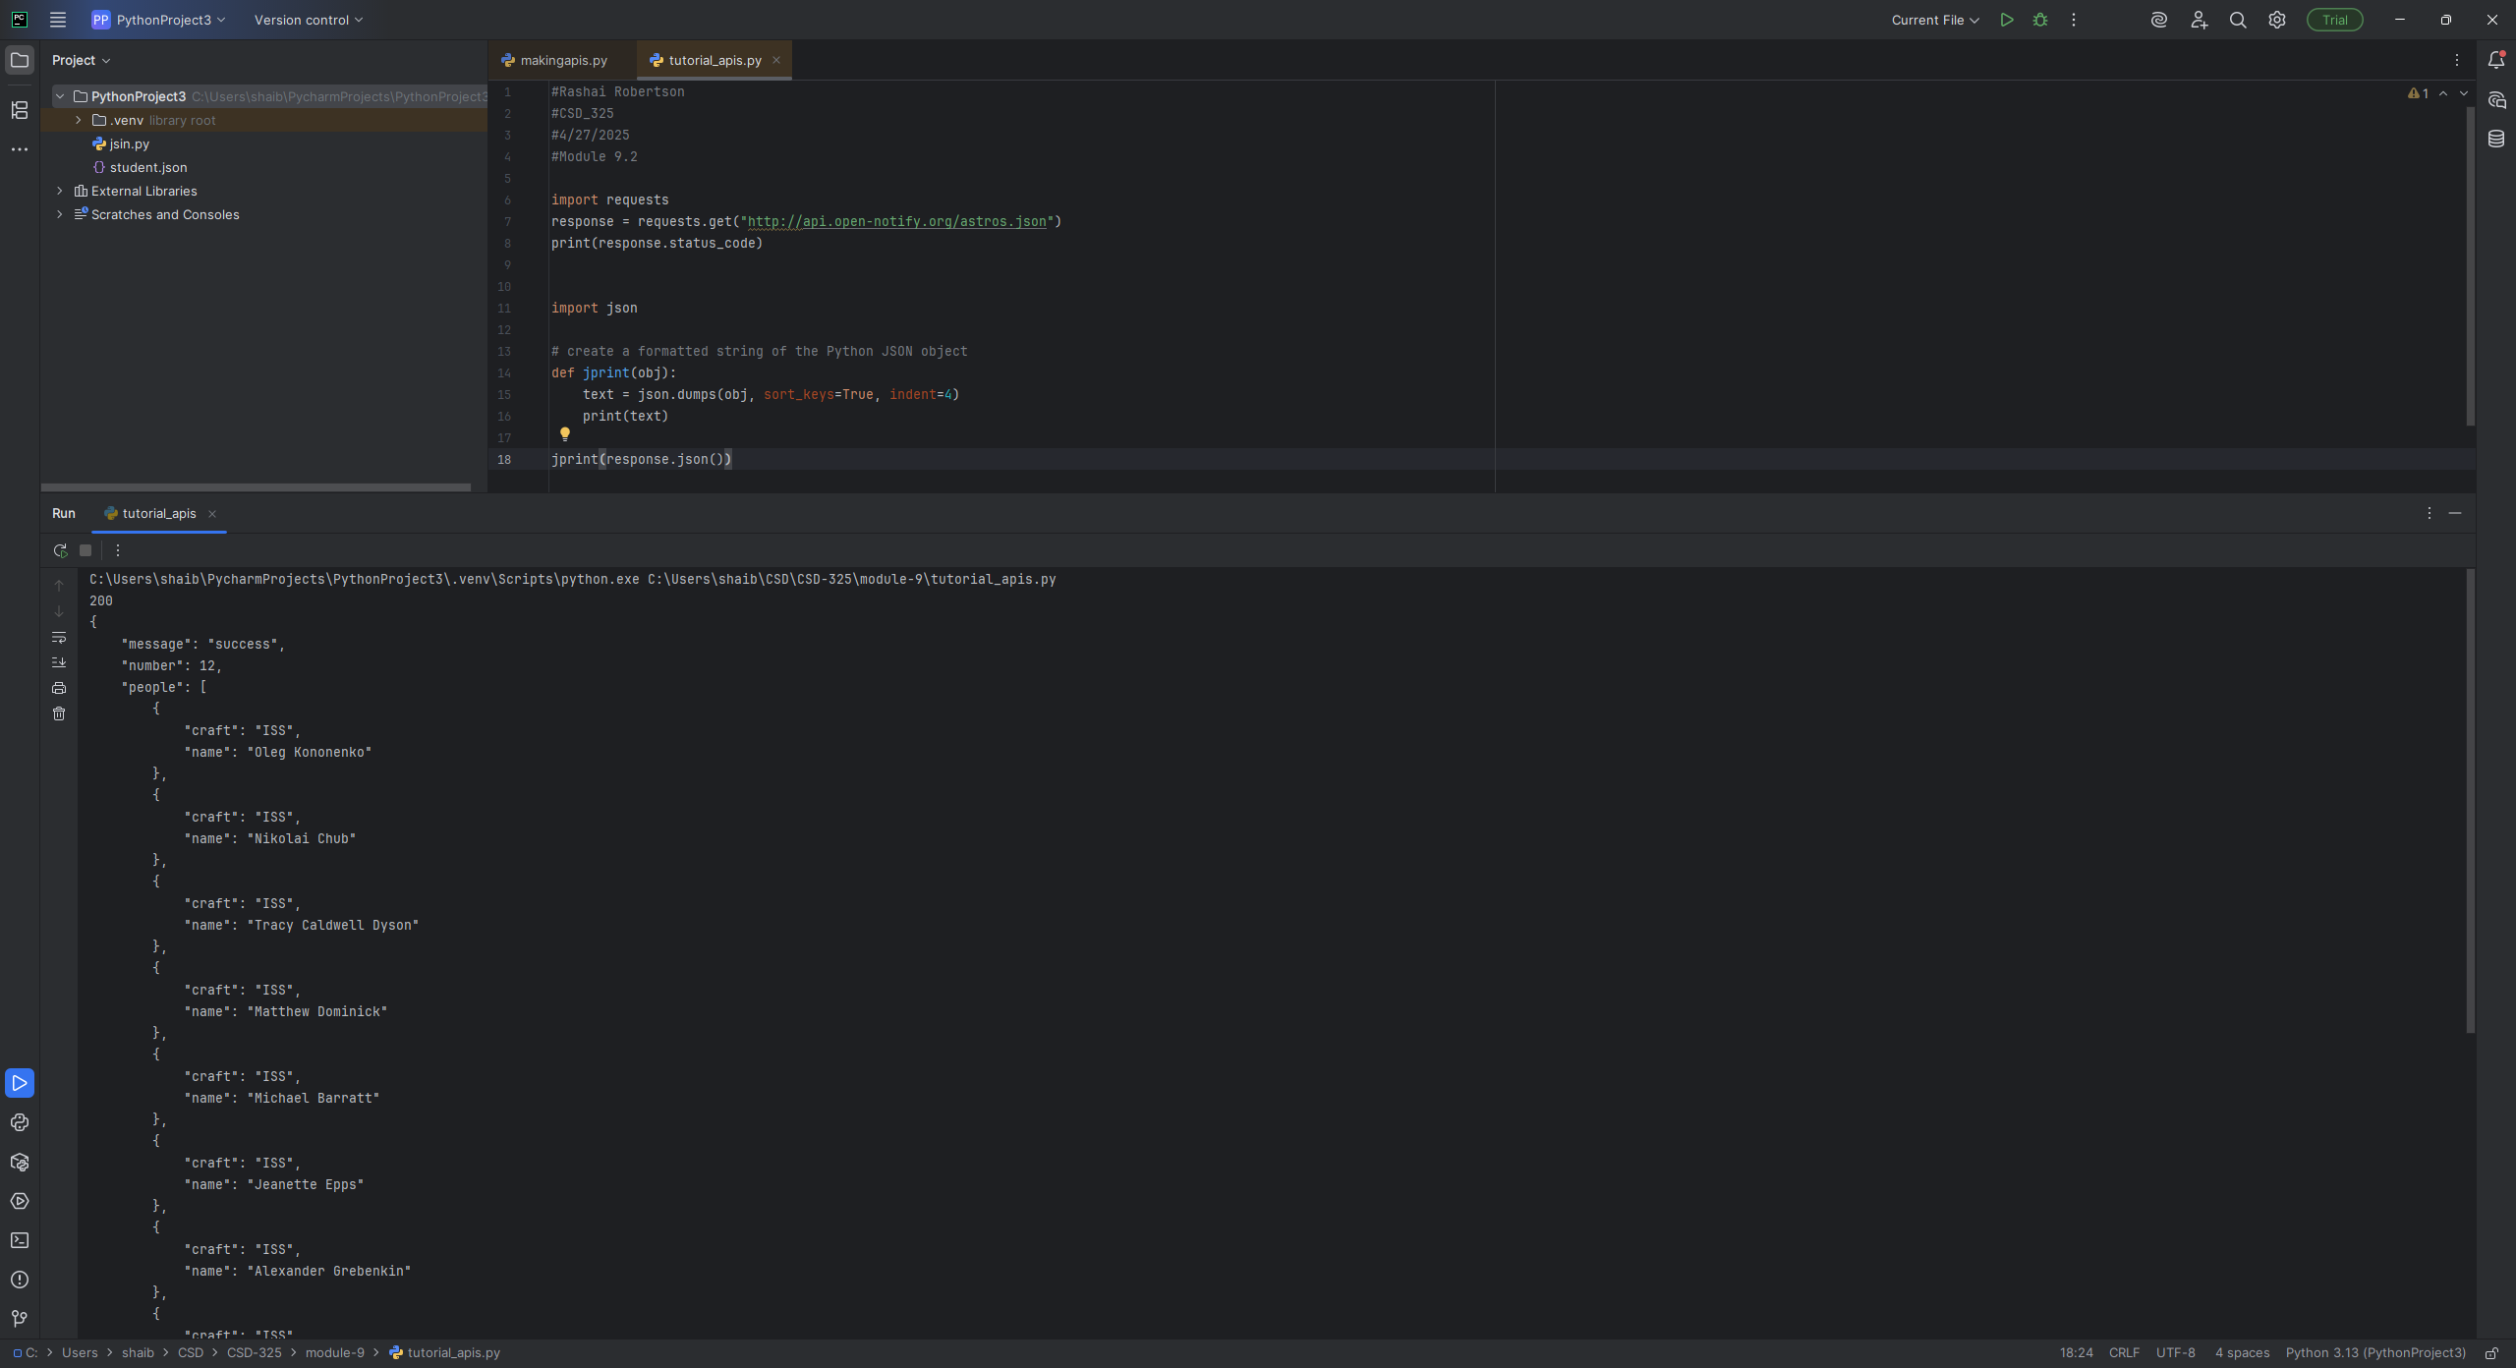

Main – Test the Connection:

: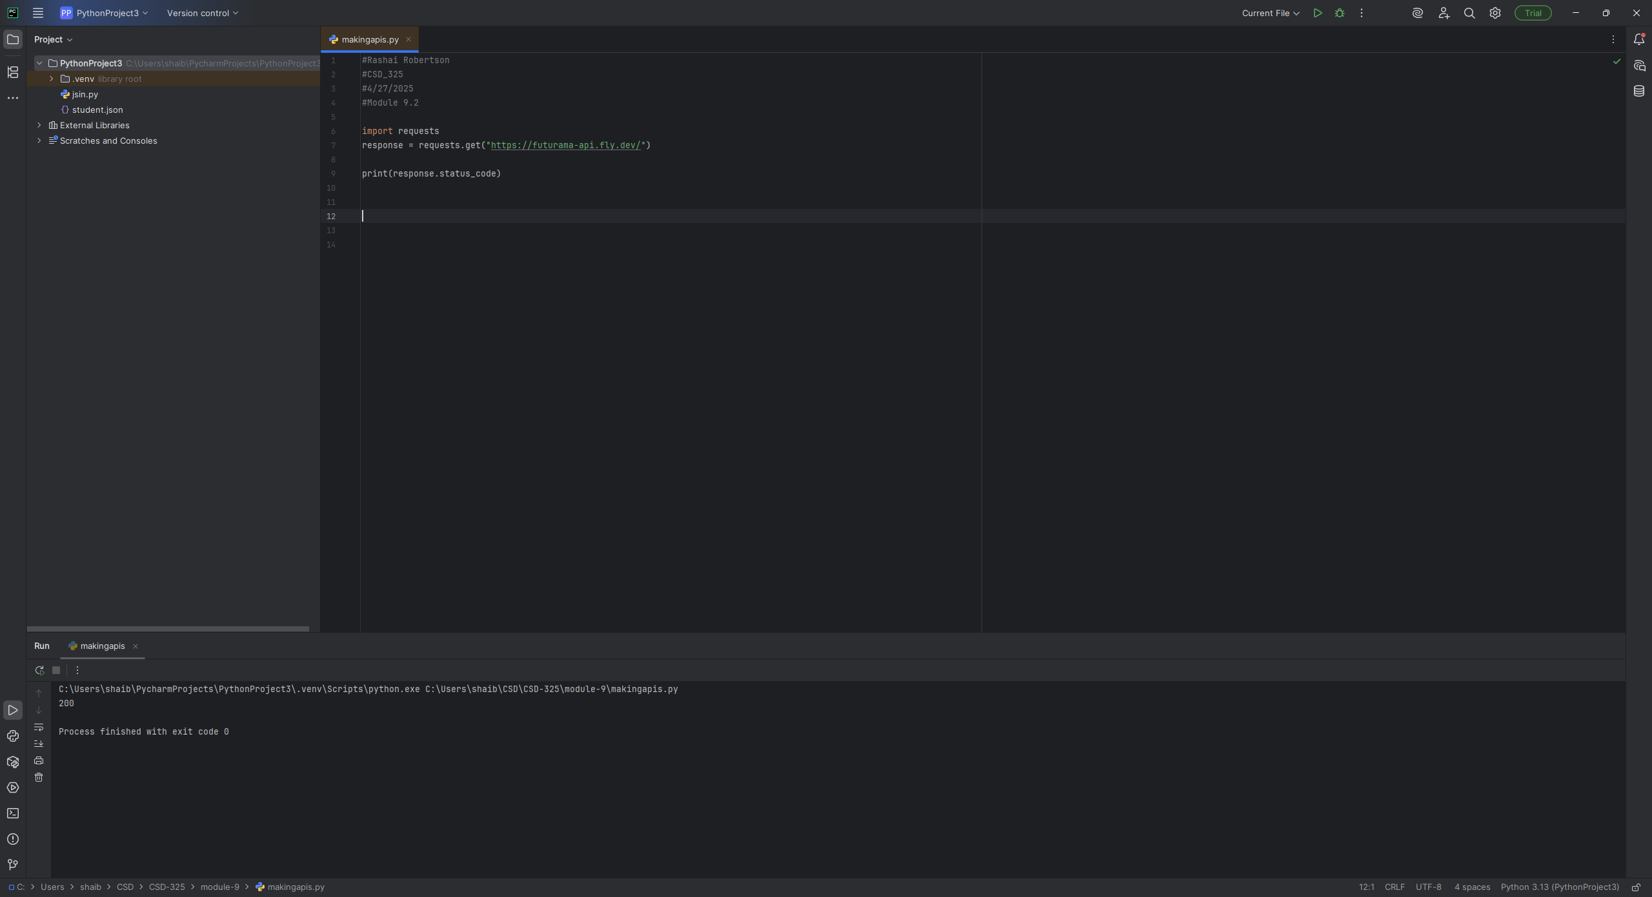

Main - Formatted:

